**Realistic Car Controller 2.2**

**by BoneCracker Games**

**Update V2.2**

*Integrated with latest NGUI (3.7.7)*

*Added NGUI Controllers*

*Added Dynamic Center of Mass*

*Added Auto Reverse function*

*Added support for multiple editing*

*Improved handling and behavior*

*Improved differantial mechanim*

*Fixed minor bugs*

**You can find more updated details on** [**http://bugra381.wix.com/bonecrackergames#!realistic-car-controller-documentation/c1z2r**](http://bugra381.wix.com/bonecrackergames#!realistic-car-controller-documentation/c1z2r)

You can make realistic vehicle behaviour with this package. Just set your wheels, and other settings, then you are ready to go. Easy to use and very highly customizable. Tested on PC and Android platforms, works with Unity Free version too!

**RCCEditor.cs**

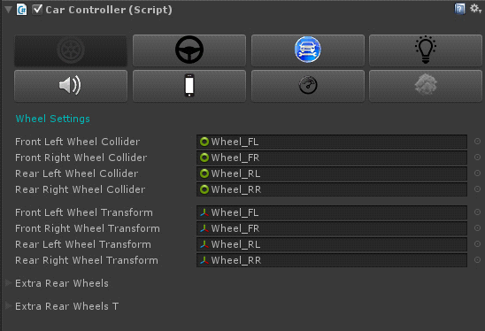

**First To Do!**

Please create these layers in order;

CarCollider, Wheel, Road and NGUI (If you will use with NGUI).

You can add layers from Edit 🡪 Project Settings 🡪 Tags and Layers 🡪 Layers.

And allways be sure your car collider’s, wheel’s, and road’s layers are correct.

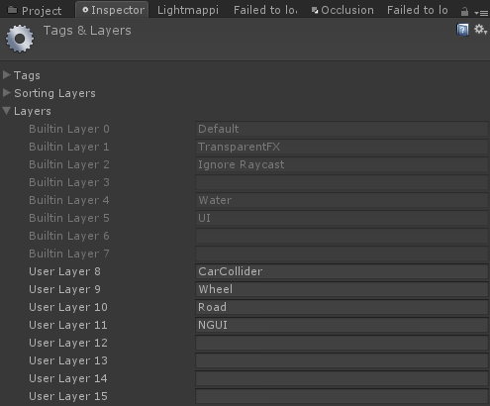

**If you have bought NGUI, just import the latest NGUI asset to your project. All NGUI controllers are ready to use in this asset. You can find prefabs in “Prefabs” folder.**

**RealisticCarControllerV2.cs**

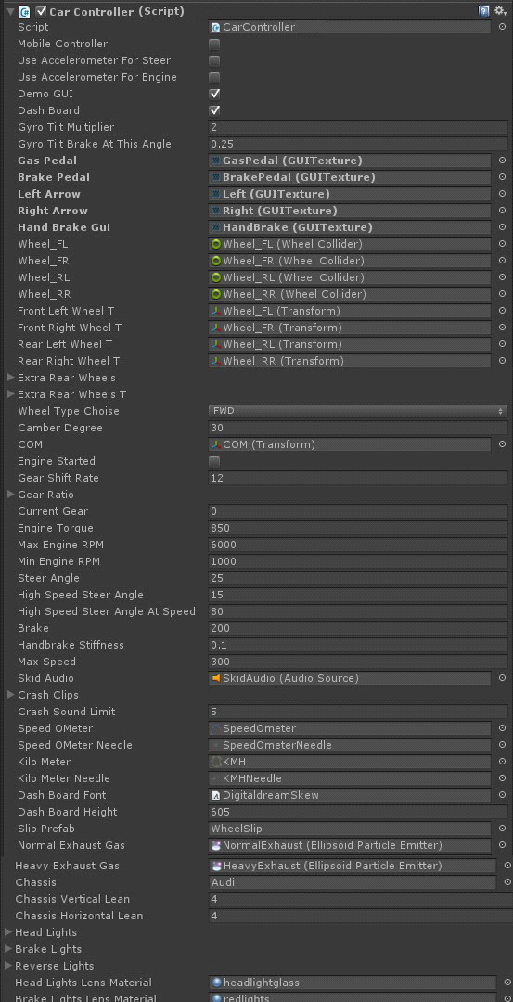

**!!!IMPORTANT!!!**

Be careful about your wheel transforms and colliders x, y, z coords. Z should be facing at forward, and Y should be facing at up. Otherwise, transforms and colliders will not act as should be. If your model coords are at wrong direction, just create an empty game object at center of the wheel, set the coords as just like i said, and parent wheel gameobject to that empty new gameobject. But if you want to do more professional and clean work, just edit pivot position in 3ds max or any other design software. And be sure that all of your wheel colliders scale is set to 1. You should get this;

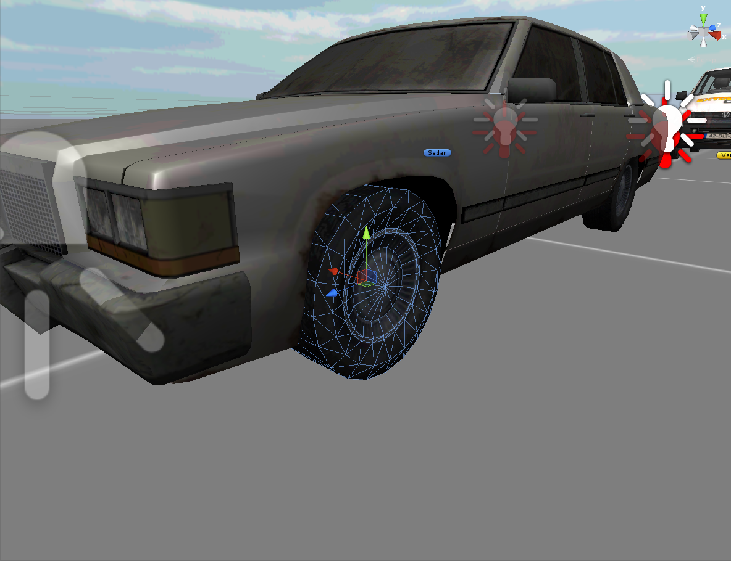

You need to change default wheel collider values for realistic handling and driving. Otherwise vehicle will act like a stone. I used these values in demo;

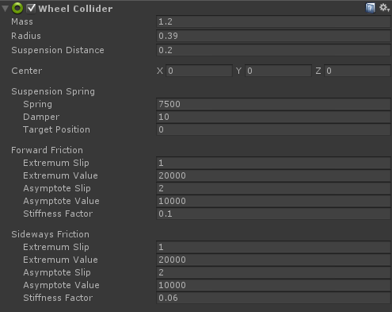

**DETAILED EXPLANATION**

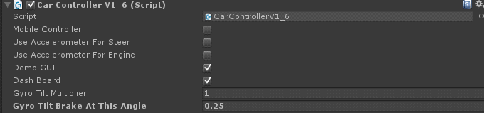

If you want to use the script on mobile devices, just turn on "Mobile Controller". This will enable touch input and disables keyboard input for controlling vehicle. For device accelerometer usement, enable "Use Accelerometer For Steer”.

DemoGUI is just displays vehicle situation. Don't use it in your retail game.

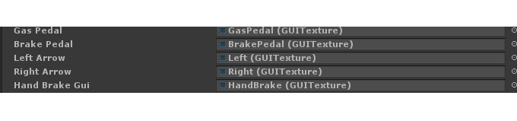

Mobile control gui. If you are planning to release your game on PC, u won't need them.

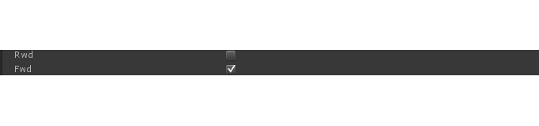

Set wheel drive of the vehicle. If you are using rwd, you have to be careful with your rear wheel collider settings and center of mass of the vehicle. Otherwise, vehicle will behave like a toy.

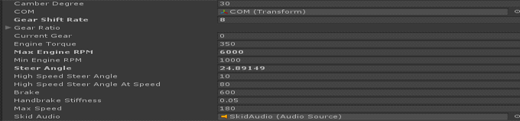

General vehicle settings. You can get many different results with tweaking these behavior settings.

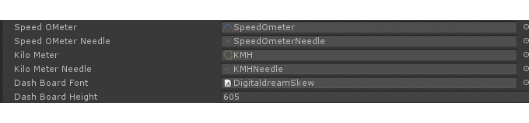

Dashboard gui, font and height. You have to be careful if you are using your own needle. Your needle image pivot is possibly different to my needle image position, you have to set your pivot position inside the script.

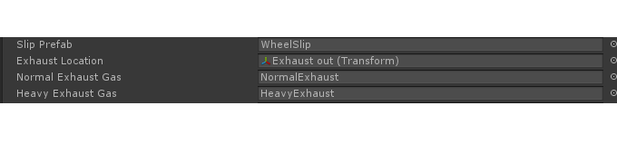

Don't choose any prefab if you don't want to use exhaust or slip effects.

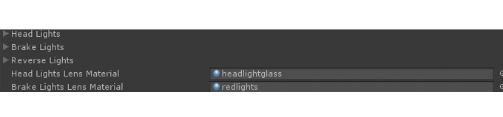

Brake, reverse and headlights. If you don't want to use them, just leave them alone.

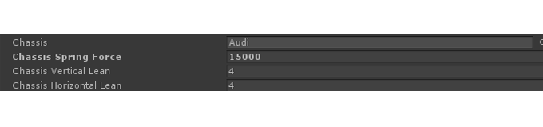

And finally chassis leaning right-left and front-back based on vehicle physics. Just select your car body game object.

**You can find more updated details on** [**http://bugra381.wix.com/bonecrackergames#!realistic-car-controller-documentation/c1z2r**](http://bugra381.wix.com/bonecrackergames#!realistic-car-controller-documentation/c1z2r)

Don't forget to attach anti rollbars and skidmark script to wheels. Antirollbars are prevents from flip over of the vehicle. If you are getting trouble with creating vehicle setup, just check demo scene and pre-configured vehicle prefabs.

I can do your request behavior such as drifting, offroad driving, or any kind of physics behavior. If you need to ask anything about package, just e-mail me!

**Contact:** [**bonecrackergames@gmail.com**](mailto:bonecrackergames@gmail.com)